SHAP Stability under Imputation Changes and False Negative Analysis in Diabetes Classification
Viên Thanh Nhã¹ and Võ Hoàng Khang^{2,*}
1 2600022649@nttu.edu.vn 2 vh.khang@hutech.edu.vn
* Corresponding author: Võ Hoàng Khang (vh.khang@hutech.edu.vn)
Abstract. This study audits diabetes classification by examining whether SHAP explanations remain stable when median imputation is replaced by mean imputation. The Pima benchmark contains 768 records, eight predictors, and 268 positive labels. Five classifiers are evaluated with training-only preprocessing; three are tuned. Evaluation uses an 80/20 holdout and one nested 5-by-5 cross-validation run. Logistic Regression is selected by training-CV F1, while tuned Random Forest obtains holdout F1 = 0.6139 on 154 records. Paired SHAP analysis fixes RF hyperparameters, seeds, and background record identifiers across the two imputation branches. Mean top-three Jaccard agreement is 0.8714 on the holdout and 0.9130 out of fold. Among records with unchanged labels, the top-three set changes for 39/150 holdout and 126/751 out-of-fold records; out-of-fold false negatives have mean Jaccard = 0.8853. The contribution is an auditable paired evaluation linked to error groups, not a new SHAP algorithm, and does not establish clinical effectiveness.
Keywords: health informatics, diabetes classification, SHAP, imputation, explanation stability, false negatives.
- Introduction
On the Pima diabetes benchmark, missed positive cases and explanation changes can occur even when aggregate performance or predicted labels appear stable. For audit-oriented health-informatics use, this raises a concrete question: how sensitive are record-level feature attributions to a routine preprocessing choice such as imputation?
We evaluate that question with a leakage-controlled classification workflow and paired SHAP analysis. Explanations are linked to record identifiers, missingness flags, and prediction configurations so that changes can be traced to individual cases rather than summarized only by global accuracy.
Three questions guide the study: (RQ1) What performance is obtained when preprocessing and model selection use training data only? (RQ2) How do SHAP rankings and signs change between median and mean imputation, including records whose labels do not change? (RQ3) How does explanation stability differ descriptively for false negatives? The study is an internal model-auditing evaluation, not a diagnostic-tool trial.
- Related Work and Contributions
SHAP attributes feature contributions to individual predictions [1], with TreeSHAP providing efficient explanations for tree models [2]; LIME uses a local surrogate around an observation [3]. These methods are established foundations rather than contributions of this study.
Prior work already covers XAI quality and diabetes prediction. Khokhar et al. [4] evaluated several explainers, including stability-related criteria, while Yeh et al. [5] formalized explanation infidelity and sensitivity. Thus, neither SHAP-based diabetes analysis nor stability assessment is claimed as novel here.
Vo et al. [6] showed that imputation can affect Shapley values independently of prediction error; Baysal Erez et al. [7] compared imputers with SHAP and surrogate models; Pandey et al. [8] used SHAP in diabetes analysis. Table 1 positions the present design against these recent studies; it is a selective comparison, not a systematic review.
Table 1. Comparison of related studies published in 2024-2026.
Study | Data and design | Reported evidence | Comparison with this study
Vo et al. (2024) [6]  Preprint v1 | California + Pima; 20-80% missingness; 5 imputers. | Shapley/MSE; prediction and explanation error can diverge. | Here: paired mean/median, stable labels, FN.
Baysal Erez et al. (2024) [7] | 3 small datasets; 7 imputers; MCAR/MNAR; RF/EBM. | SHAP RMSE + surrogate evaluation; objective-dependent imputer choice. | Here: diabetes ranks, signs, error groups.
Khokhar et al. (2025) [4]  Preprint | Diabetes Binary Health Indicators; several models/XAI. | SHAP/LIME/EBM; stability, fidelity, consistency. | Here: fixed model settings and background IDs.
Pandey et al. (2026) [8]  Preprint v1 | NCSU Diabetes + Pima + Ohio. | 5-fold CV; SHAP aggregate tree-model ranks. | Here: record-level changes linked to FN.
This study | Pima; holdout + nested 5 x 5 CV; paired RF. | Jaccard, Spearman, L1, signs; unchanged-label/FN groups. | Auditable paired evidence; no external validation.
Metrics from prior studies are summarized within their own designs and are not ranked directly against the F1 or Jaccard values reported here. The comparison identifies scope differences without claiming that earlier work lacks every component used in this study.
The contribution is a paired median-versus-mean evaluation on the same records with fixed RF hyperparameters and background identifiers, covering SHAP ranks, magnitudes, signs, unchanged-label records, and false negatives in holdout and out-of-fold predictions. It adds record-level audit evidence on Pima without proposing a new SHAP algorithm or claiming absolute priority.
- Data and Classification Models
  - Data and Scope of Inference
The Pima dataset contains 768 rows and eight predictors. Its original class labels were re-encoded as Outcome in {0,1}, yielding 500 negative and 268 positive records; direct inspection found no duplicate rows or NULL entries before the zero-value rule. The documented population is adult women of Pima heritage [9]. The task classifies existing labels, and neither generalization to Vietnamese populations nor clinical use is established.
Table 2. Features and missing-value counts after applying the zero-value rule.
Feature | Description | Zero-value rule
Pregnancies | Number of pregnancies | Retained: 0 missing
Glucose | Glucose measure | 0 to missing: 5
BloodPressure | Diastolic blood pressure | 0 to missing: 35
SkinThickness | Skinfold thickness | 0 to missing: 227
Insulin | Insulin concentration | 0 to missing: 374
BMI | Body mass index | 0 to missing: 11
DiabetesPedigreeFunction | Diabetes pedigree function | Retained: 0 missing
Age | Age | Retained: 0 missing
  - Preprocessing and Data Leakage Control
Column names, numeric types, labels, duplicates, and missing-value conventions were checked before modeling. Zeros in five measurement columns were pre-specified as missing; imputation and scaling parameters for the main analysis were estimated only from the corresponding training partition. Records were not removed solely for missingness, and the original missingness mask was retained for explanation displays.
The main branch uses a Pipeline of SimpleImputer, StandardScaler, and classifier so learned preprocessing is fitted only on training data or the current training fold [10]. A separate diagnostic leakage-sensitivity comparison applies median imputation before splitting; it is intentionally not leakage-free and is excluded from model selection and primary conclusions.
  - Benchmark Models
Baselines are Logistic Regression (max_iter=1000), Decision Tree (max_depth=5), Random Forest (100 trees, max_depth=5), RBF-SVM (C=1, gamma=scale), and KNN (k=5), with random_state=42 where supported. StandardScaler is kept in the common pipeline for workflow consistency; RF scaling is examined only as a diagnostic ablation. RF is used for SHAP because it supports tree-based explanation workflows, not because it has the highest F1.
- XAI Framework and Stability Evaluation
  - Global and Record-Level Explanations
For a trained model f and a record x, the additive SHAP representation is [1]:
f(x) = φ₀ + Σⱼ₌₁⁸ φⱼ(x). (1)
Here, φ0 is the baseline output and φj(x) is feature j's contribution. The target is the RF class-1 probability after imputation and scaling. The implementation first attempts interventional TreeSHAP with model_output=probability [11]. A pre-specified additivity check requires the baseline plus contributions to match the predicted probability within 1e-5; otherwise that explanation is discarded and recomputed by enumerating all 256 feature subsets against the same finite background, followed by a second additivity check. Reported predictions are never altered to force agreement. The pre-specified tolerance and fallback are reported because additivity behavior can depend on the software implementation.
Each background contains 60 training-record identifiers sampled without replacement with NumPy default_rng (seed 42 for holdout; 42 + fold number for nested CV). The paired branches share background IDs but transform them with their own fitted pipelines. SHAP differences therefore reflect imputation, retrained trees, and transformed background values together; no test or outer-validation record enters its corresponding background.
Global importance is mean absolute SHAP across evaluation records. Figure 1 summarizes global ranks, Figure 2 shows one false negative, and the demonstration interface retains original values and imputation flags.
  - Explanation Stability
Let T3^(a)(x) be the three features with largest |phi| for record x under configuration a; k=3 is fixed before execution and ties use the fixed column order. Agreement is:
J₃(x; a,b) = |T₃⁽ᵃ⁾(x) ∩ T₃⁽ᵇ⁾(x)| / |T₃⁽ᵃ⁾(x) ∪ T₃⁽ᵇ⁾(x)|. (2)
We also compute Spearman correlation between the two |SHAP| rank vectors and L1 shift D(x;a,b)=sum_j |phi_j^(a)(x)-phi_j^(b)(x)|. Sign changes are counted only when |phi|>1e-4 in both branches; records with no eligible feature are undefined. L1 values are interpreted only on the selected output scale.
Statistics are reported for all records and for unchanged-label records, isolating cases where decisions remain stable while explanations vary. Explanation stability is a consistency criterion, not evidence of medical correctness [5].
- Experimental Design
  - Evaluation Protocols
A stratified 80/20 holdout (random_state=42) gives 614 training records (400 negative, 214 positive) and 154 test records (100 negative, 54 positive). Training uses five-fold StratifiedKFold with shuffle=True, random_state=42, optimizing class-1 F1. A second evaluation is one nested 5 × 5 CV run over all 768 records, with outer seed 42 and inner seed 42+fold (1-5). Every learned preprocessing step is fitted inside the corresponding training fold; this is internal retrospective validation, not repeated nested CV or external validation.
Labels use estimator.predict(): SVM uses the sign of its decision function; the other models choose the highest-probability class, with class 0 on ties. No SVM calibration or threshold optimization is applied. Tables report Accuracy, class-1 Precision/Recall/F1 and ROC AUC where applicable; SVM AUC uses decision margins and other models use class-1 probabilities.
  - Controlled Comparisons
Controlled comparisons include the preprocessing diagnostic, an eight-row holdout benchmark, five RF ablations, one nested-CV run, and paired median/mean SHAP analysis. Search grids are RF: n_estimators {100,200,300} x max_depth {3,5,8,None} x min_samples_split {2,5,10} (36); SVM: C {0.1,1,10,100} x gamma {scale,0.01,0.1} x kernel {rbf,linear} (24); KNN: k {3,5,7,9,11} x weights {uniform,distance} x p {1,2} (20). LR and DT remain baseline. For each XAI pair, RF hyperparameters selected in the median branch are held fixed when retraining the mean branch.
  - False Negative Analysis and Uncertainty
False negatives (FN) have true label 1 and predicted label 0. XAI statistics are reported for all records, unchanged-label records, and FN/TP/FP/TN groups defined by the median-imputation RF. The illustrated holdout case is the FN with the lowest class-1 probability (first in test order on ties), avoiding subjective case selection.
Each record receives one out-of-fold prediction per method. Metrics are summarized by mean and sample SD across the five outer folds; overlapping training sets mean this SD is not a confidence interval. OOF SHAP statistics pool 768 unique records. The analysis is descriptive, with no significance tests or confidence intervals. 'CV selected' chooses the highest inner-CV F1 model within each outer fold and evaluates it on that fold.
- Experimental Results
  - Holdout Classification Results
Table 4 reports the saved holdout results. DT has the highest observed test F1, but LR has the highest training-CV F1 (0.6545) and is therefore selected by the pre-specified internal rule; the test set is not used for algorithm choice. Tuned RF uses 200 trees, max_depth=None, and min_samples_split=2, selected by training CV with fold-specific preprocessing.
Table 4. Holdout classification results and training-CV F1.
Model | CV F1 | Accuracy | Precision | Recall | F1
LR | 0.6545 | 0.7078 | 0.6000 | 0.5000 | 0.5455
DT | 0.5877 | 0.7597 | 0.6393 | 0.7222 | 0.6783
RF | 0.6389 | 0.7403 | 0.6667 | 0.5185 | 0.5833
SVM | 0.6485 | 0.7403 | 0.6522 | 0.5556 | 0.6000
KNN | 0.5939 | 0.7532 | 0.6600 | 0.6111 | 0.6346
Tuned RF | 0.6528 | 0.7468 | 0.6596 | 0.5741 | 0.6139
Tuned SVM | 0.6524 | 0.7013 | 0.5909 | 0.4815 | 0.5306
Tuned KNN | 0.6366 | 0.7403 | 0.6346 | 0.6111 | 0.6226
LR: Logistic Regression; DT: Decision Tree; RF: Random Forest. Tuned CV scores reuse the selection CV and may be optimistic; nested CV evaluates the selection procedure.
  - Random Forest Ablation
Table 5 is a diagnostic RF ablation on the same holdout. Median and mean imputation both yield F1=0.6139 but need not produce identical explanations. The no-scaling branch yields F1=0.6000; because RF is theoretically insensitive to monotone feature scaling, this single-run difference is treated only as implementation-level sensitivity and not as evidence that scaling benefits tree models. None of the ablations is used for model selection.
Table 5. RF ablation on the holdout set.
Variant | Accuracy | Precision | Recall | F1
Full pipeline | 0.7468 | 0.6596 | 0.5741 | 0.6139
Retain zeros | 0.7468 | 0.6531 | 0.5926 | 0.6214
No scaling (diagnostic) | 0.7403 | 0.6522 | 0.5556 | 0.6000
Mean imputation | 0.7468 | 0.6596 | 0.5741 | 0.6139
Baseline RF | 0.7403 | 0.6667 | 0.5185 | 0.5833
From saved predictions, tuned RF gives TN=84, FP=16, FN=23, TP=31; DT gives 78, 22, 15, 39. RF therefore has fewer false positives but more missed positives on this holdout, which is insufficient by itself for practical model choice.
  - Nested Cross-Validation Evaluation
Table 6 reports mean ± sample SD over the five outer folds. RF, SVM, and KNN are tuned inside each fold; LR and DT remain baseline. These OOF estimates evaluate the training procedure across the benchmark and are not directly equivalent to the 154-record holdout.
Table 6. Nested 5 × 5 CV with a single partitioning run.
Model | Accuracy | Recall | F1 | ROC AUC
CV selected | 0.7526 ± 0.0124 | 0.6006 ± 0.0445 | 0.6283 ± 0.0232 | 0.8142 ± 0.0180
DT | 0.7108 ± 0.0503 | 0.5593 ± 0.1730 | 0.5641 ± 0.1087 | 0.7580 ± 0.0521
KNN | 0.7487 ± 0.0139 | 0.5747 ± 0.0343 | 0.6146 ± 0.0180 | 0.8047 ± 0.0046
LR | 0.7721 ± 0.0185 | 0.5711 ± 0.0529 | 0.6358 ± 0.0235 | 0.8366 ± 0.0227
RF | 0.7538 ± 0.0226 | 0.5930 ± 0.0738 | 0.6253 ± 0.0518 | 0.8275 ± 0.0202
SVM | 0.7513 ± 0.0078 | 0.5674 ± 0.0421 | 0.6137 ± 0.0193 | 0.8164 ± 0.0164
The inner-CV selection procedure achieves F1=0.6283 ± 0.0232 and Accuracy=0.7526 ± 0.0124. Outer-fold scores are not reused to select an algorithm and then presented as an unbiased estimate of that same choice.
  - XAI Results and False Negative Analysis
Table 7. SHAP stability when replacing median with mean imputation.
Group | n | Top-3 Jaccard | Spearman | L1 SHAP | Sign changes
Test All | 154 | 0.8714 | 0.9212 | 0.0452 | 0.0335
Test Unchanged labels | 150 | 0.8680 | 0.9222 | 0.0445 | 0.0335
Test FN | 23 | 0.8348 | 0.8975 | 0.0523 | 0.0380
OOF All | 768 | 0.9130 | 0.9446 | 0.0328 | 0.0415
OOF Unchanged labels | 751 | 0.9157 | 0.9454 | 0.0323 | 0.0411
OOF FN | 109 | 0.8853 | 0.9404 | 0.0328 | 0.0406
OOF denotes out of fold. On the holdout, 150/154 records keep their label and 115/154 keep the same top-three features; across OOF records the counts are 751/768 and 635/768. Even among unchanged-label records, top-three features change for 39/150 holdout and 126/751 OOF records (16.78%). OOF false negatives have mean Jaccard 0.8853 versus 0.9130 overall; this is descriptive, not a tested population difference. Sign change is the mean eligible-feature rate with |SHAP|>1e-4 in both branches.
Interventional TreeSHAP did not meet the pre-specified 1e-5 additivity tolerance in any of the 12 explanation runs, so those outputs were discarded. All reported tables and figures use the exhaustive-subset fallback over 256 coalitions with a 60-record background; its maximum additivity error was 4.44e-16. The exhaustive calculation is exact only relative to this finite background, not the population distribution.
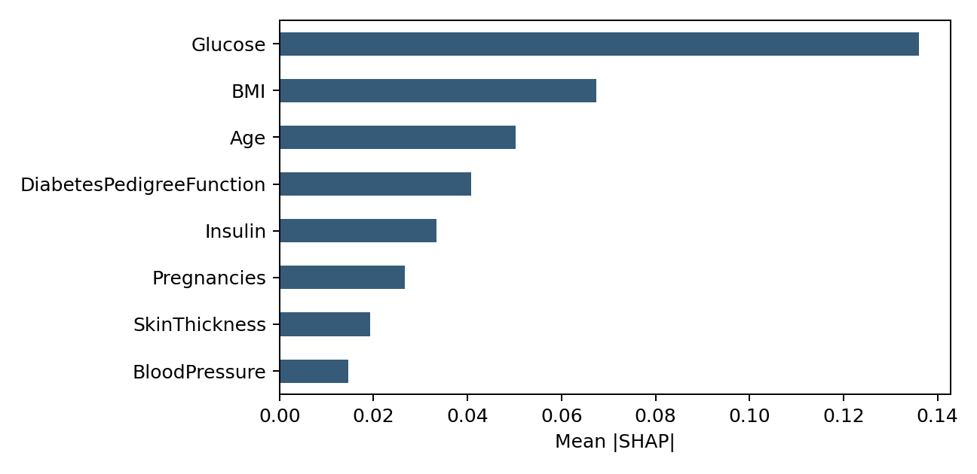
Fig. 1. Global SHAP importance of the tuned RF on 154 test records.
The three features with the highest mean |SHAP| in this run are Glucose (0.1360), BMI (0.0675), and Age (0.0503). This ranking describes the model and dataset under study, not an ordering of medical causes.
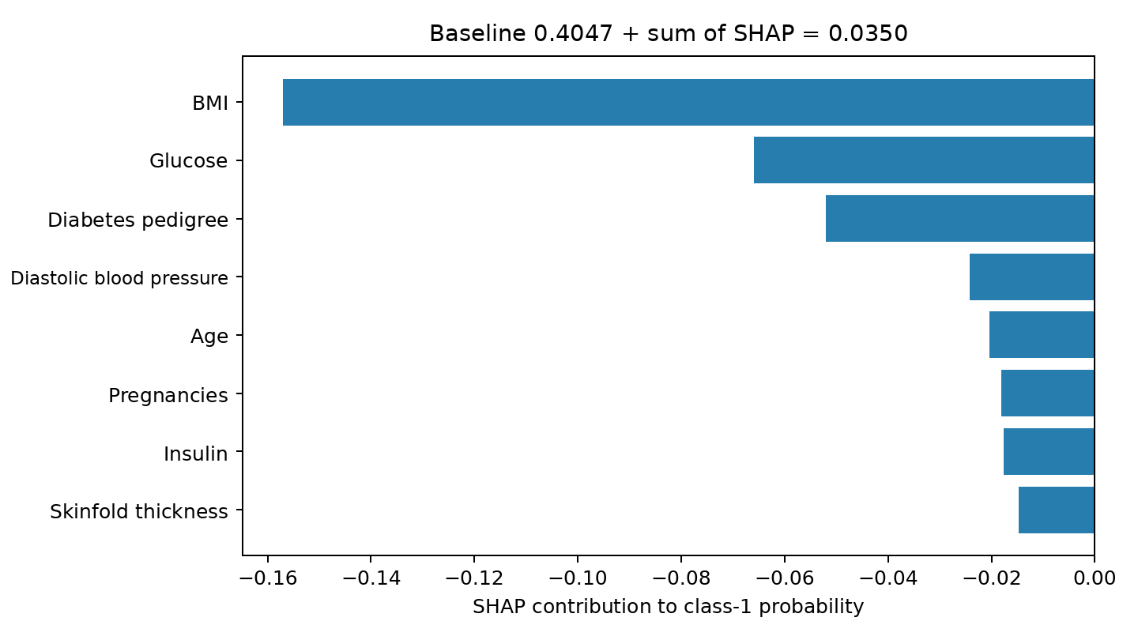
Fig. 2. SHAP contributions for the lowest-probability test FN, row_id = 419.
- Discussion and Application Prospects
  - Implications for Health Informatics
For audit-oriented deployment, a prediction record should link its identifier, output, feature contributions, imputation flags, and processing configuration. The result that 126/751 OOF records retain their label but change top-three features shows that label monitoring alone can miss variation in explanatory information. This supports explanation-quality monitoring, not a claim of improved clinical decisions.
For row_id=419, RF class-1 output is 0.0350 versus baseline 0.4047, with summed contributions matching within tolerance. This describes model behavior only; SHAP signs are not causal effects or treatment indications.
  - Study Limitations
Generalizability is limited by the small, narrowly defined dataset. Missingness may reflect collection processes that simple imputation cannot recover, and correlated features can redistribute SHAP contributions according to the background and explainer assumptions. Stability can coexist with data bias, while instability alone does not make a model unusable.
Median and mean imputation yield the same holdout F1 but different explanations, consistent with [6,7]. The paired experiment changes imputed values, retrained trees, and transformed backgrounds simultaneously, so it does not isolate a single source of variation. Multiple seeds, backgrounds, thresholds, and formal tests between error groups remain future work.
Application would require independent target-population validation, verified label definitions, probability calibration, and usability studies with healthcare professionals; none is established here.
- Conclusion
This study audits Pima diabetes classifiers by pairing predictive evaluation with SHAP stability under median-versus-mean imputation. Tuned RF obtains holdout F1=0.6139, while LR is selected by training-CV F1. Top-three Jaccard is 0.8714 on the holdout and 0.9130 OOF; 126/751 unchanged-label OOF records change their top-three features, and OOF FN Jaccard is 0.8853. The contribution is a record-level paired audit design and error-group analysis, not a new explainer; external validation is required before any clinical interpretation.

References
- Lundberg, S.M., Lee, S.-I.: A unified approach to interpreting model predictions. In: Advances in Neural Information Processing Systems, vol. 30 (2017).
- Lundberg, S.M., et al.: From local explanations to global understanding with explainable AI for trees. Nature Machine Intelligence 2, 56-67 (2020). https://doi.org/10.1038/s42256-019-0138-9.
- Ribeiro, M.T., Singh, S., Guestrin, C.: "Why should I trust you?": Explaining the predictions of any classifier. In: Proceedings of the 22nd ACM SIGKDD International Conference on Knowledge Discovery and Data Mining, pp. 1135-1144 (2016). https://doi.org/10.1145/2939672.2939778.
- Khokhar, P.B., Pentangelo, V., Palomba, F., Gravino, C.: Towards transparent and accurate diabetes prediction using machine learning and explainable artificial intelligence. arXiv:2501.18071 (2025).
- Yeh, C.-K., Hsieh, C.-Y., Suggala, A., Inouye, D.I., Ravikumar, P.K.: On the (in)fidelity and sensitivity of explanations. In: Advances in Neural Information Processing Systems, vol. 32, pp. 10965-10976 (2019).
- Vo, T.L., Nguyen, T., Hammer, H.L., Riegler, M.A., Halvorsen, P.: Explainability of machine learning models under missing data. arXiv:2407.00411v1 (2024).
- Baysal Erez, I., Flokstra, J., Poel, M., van Keulen, M.: The impact of missing data imputation on model performance and explainability. In: BNAIC/BeNeLearn (2024).
- Pandey, V., Laskar, R.H., Tewari, R.: A unified three-stage machine learning framework for diabetes detection, subtype discrimination, and cognitive-metabolic hypothesis testing. arXiv:2605.13464v1 (2026).
- OpenML: Diabetes/Pima Indians Diabetes, dataset ID 37. https://www.openml.org/d/37
- Scikit-learn developers: Common pitfalls and recommended practices. https://scikit-learn.org/stable/common_pitfalls.html, last accessed 2026/09/13.
- SHAPdevelopers:shap. TreeExplainer. https://shap.readthedocs.io/en/latest/generated/shap.TreeExplainer.html, last accessed 2026/09/13.

